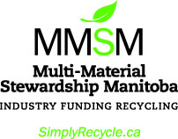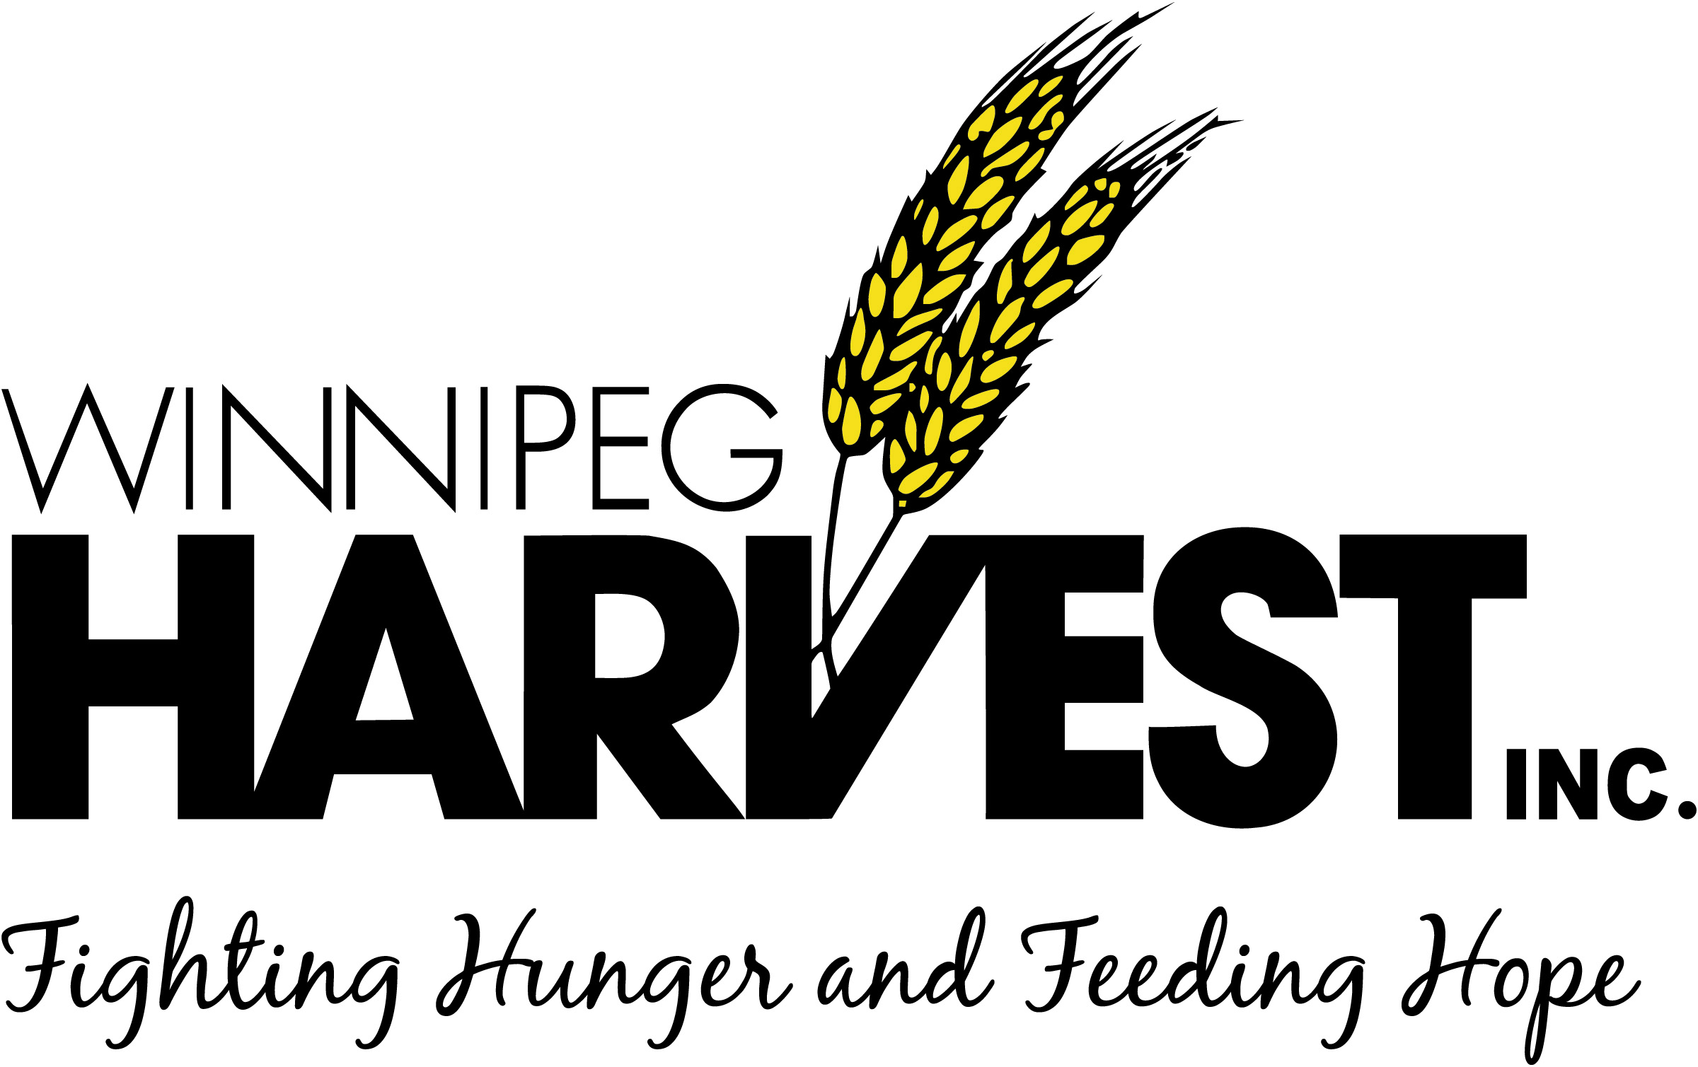

**MEDIA RELEASE**

**Students “Bag it Forward” with 4,910 bags for Winnipeg Harvest**

**March 19, 2019**

**WINNIPEG—**UWinnipeg PACE students donated 4,910 bags today, through the *Bag it Forward: Plastic Bag Recycling Program*, helping Winnipeg Harvest create food kits for families-in-need.

The donated bags are part of a joint-partnership between Multi-Material Stewardship Manitoba (MMSM) and Winnipeg Harvest. Members of the program, including UWinnipeg, collect plastic bags in receptacles placed on-site. The program aims to decrease Manitoban’s ecological footprint and help hungry families.

“One of the things we are learning at UWinnipeg PACE is how to be part of our community, and this seemed like a simple way to make a difference,” says Ankeet Mahadik, the student reprenstative. “We all know we should use less plastic, but it’s not always possible. So, why not get as much life out of the plastic bags as possible?”

Donated plastic bags make it possible for Winnipeg Harvest to make food kits, for the nearly 64,000 Manitobans it feeds each month.

“At Winnipeg Harvest, we understand how important it is to reclaim what often gets overlooked, left behind or discarded. We reclaim food and people. To get food to people, we reclaim plastic bags—more than one million per year—to pack food kits. Thank you UWinnipeg PACE and MMSM, for helping us reclaim plastic bags,” says Colleen McVarish, the assistant director of development at Winnipeg Harvest.

**-30-**

**About UWinnipeg PACE:** Located in the Buhler Centre, Professional, Applied and Continuing Education (PACE) programs at UWinnipeg offer professional education to students who are willing to pursue specialized hands-on education in professional fields.

**About Winnipeg Harvest:** Winnipeg Harvest is a not-for-profit, community-based organization that collects and shares surplus food for individuals and families-in-need.

**About MMSM:** MMSM is a not-for-profit, industry-funded organization, that funds and provides support for the province’s residential recycling programs for packaging and printed paper. Its goal is to promote the reduction, reuse and recycling of the materials managed in its program while increasing recovery rates.

**For more information:** Ankeet Mahadik | Student Representative | UWinnpeg PACE | **204.962.2605** | [ankeetmahadik2605@gmail.com](mailto:ankeetmahadik2605@gmail.com)